Analysis of Precipitation and Temperature Extremes over the
Muda River Basin, Malaysia (max 25 words)

Author^{1,*}, Author ², Author ¹

¹ Geoinformatic Unit, Geography Section, School of Humanities, Universiti Sains Malaysia, 11800 USM, Penang.
² History Section. School of Social Humanities, Universiti Sains Malaysia, 11800 USM, Penang.

*Correspondence: author1@usm.my

Received: XX Jan 2021, Revised: XX Feb 2021; Accepted: XX Mar 2021; Published XX Apr 2021

Abstract: A summary of the content of the manuscript. A well-written abstract should consist of background, purpose, methods, results and conclusion (max 250 words)

Keywords: Keyword1; Keyword2;.. (max five keywords)

- Introduction
The introduction section should provide readers with the background information of the studied topic. Besides that, authors should summarize the literature and state the research problem/issue/gap clearly. Please make sure your citations are well balanced, relevant and up-to-date.

- Study Area
A brief geographical description of study area with at least one figure to show the location. A standard map should contain coordinates, north arrow, scale and legend.

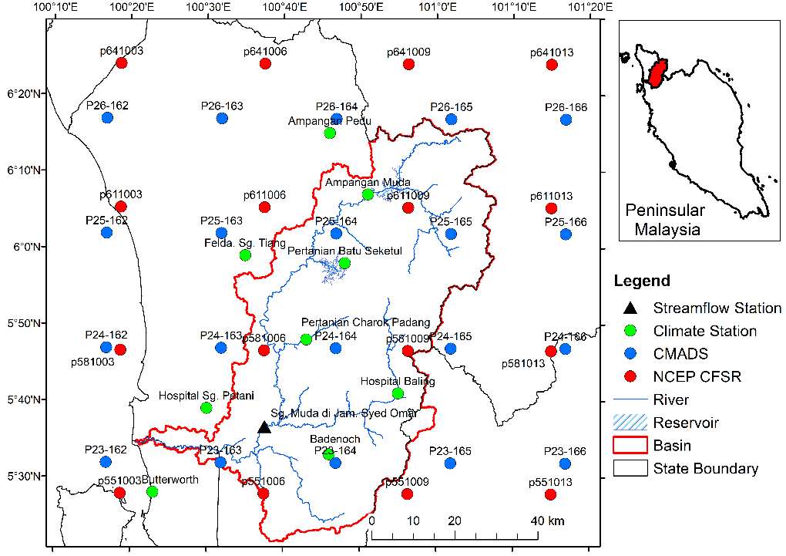
Figure 1: Example study area map.

- Materials and Methodology
  - Materials
A brief geographical description of study area with at least one figure to show the location. A standard map should contain coordinates, north arrow, scale and legend.

Table 1:
No | Name | Latitude | Longitude
1 | XX | XX | XX
2 | XX | XX | XX
3 | XX | XX | XX
4 | XX | XX | XX

  - Methodology / framework / theory
Please describe the overall workflow of your study as details as possible. We encourage to prepare a figure represents the entire workflow / framework / theory.

- Results
  - Result 1
In the results section, simply describe the major research findings that you discovered.

  - Result 2

  - Result 3
- Discussion
This section should answer the questions of what do your results mean? Compare your results with those from other similar studies, either your results similar or difference with other works. Please provide reasons the statements. In addition, you can also include limitations of current work and some suggestions to improve in the future.

- Conclusions
This section should summarize the findings as simple as possible. Authors do not need to include statistical values that have been mentioned previously in the results section.

Acknowledgement: Authors should acknowledge individuals, institutions, funding bodies, technical contributors, or other sources of support that contributed to the study but do not meet the criteria for authorship. Example: “The authors gratefully acknowledge [institution/person/funding agency] for providing [financial/technical/research] support for this study.”

Data Availability: Authors should state where the data supporting the findings of the study can be accessed. If the data cannot be made publicly available, authors should explain the reason and indicate how the data may be accessed, where appropriate. Example: “The data supporting the findings of this study are available from the corresponding author upon reasonable request.”

Author Contributions: Authors should specify each author’s individual contributions to the study using relevant roles such as conceptualisation, methodology, investigation, data curation, formal analysis, writing, supervision, and project administration, followed by the author’s name or initials. Example: “Conceptualisation: Author 1; Methodology: Author 1 and Author 2; Data curation: Author 2; Formal analysis: Author 1; Writing – original draft: Author 1; Writing – review and editing: Author 1 and Author 2; Supervision: Author 2.”

Conflicts of Interest: Authors should disclose any financial, professional, personal, or other relationships that could potentially influence the research. If there are no conflicts of interest, authors should state this explicitly. Example: “The authors declare that there are no conflicts of interest related to this study.”

Ethics Statement: Authors should indicate whether ethical approval was required and, where applicable, provide the name of the ethics committee and approval number. For studies that do not involve human participants, identifiable personal data, or other ethically regulated materials, authors should state that ethical approval was not required. Example: “Ethical approval was not required as the study involved no human participants or identifiable personal data.”
References
Authors should use APA 7th edition style for all in-text citations and references. The reference list should be arranged alphabetically by the surname of the first author. Authors should provide a DOI or URL where available. Examples of common reference types are provided below.

1. Journal Article
Format: Author, A. A., & Author, B. B. (Year). Title of article. Title of Journal, volume(issue), page–page. https://doi.org/xxxxx

Example: Wang, L., & Zhang, Y. (2023). Sustainable tourism development in protected areas. Journal of Sustainable Tourism, 31(4), 567–582. https://doi.org/10.xxxx/xxxxx

In-text citation: (Wang & Zhang, 2023)

2. Journal Article with Three or More Authors

Example: Rahman, M. A., Hassan, S., Lee, J., & Chen, Y. (2024). Climate change adaptation and community resilience in coastal areas. Applied Geography, 165, 103245. https://doi.org/10.xxxx/xxxxx

In-text citation: (Rahman et al., 2024)

3. Book
Format: Author, A. A. (Year). Title of book. Publisher. https://doi.org/xxxxx

Example: Butler, R. W. (2020). Tourism and resilience. Channel View Publications.

In-text citation: (Butler, 2020)

4. Chapter in an Edited Book
Format: Author, A. A. (Year). Title of chapter. In A. A. Editor (Ed.), Title of book (pp. xx–xx). Publisher. https://doi.org/xxxxx

Example: Hall, C. M. (2021). Tourism, sustainability, and climate change. In J. Smith (Ed.), Contemporary issues in tourism (pp. 45–62). Routledge.

In-text citation: (Hall, 2021)

5. Newspaper or News Article
Format: Author, A. A. (Year, Month Day). Title of article. Name of Newspaper. URL

Example: Tan, M. L. (2025, June 15). Malaysia strengthens efforts to promote sustainable tourism. The Star. https://www.thestar.com.my/

In-text citation: (Tan, 2025)

6. Website
Format: Author/Organisation. (Year, Month Day). Title of webpage. Website Name. URL

Example: United Nations. (2024, September 20). Sustainable development goals. United Nations.https://www.un.org/sustainabledevelopment/

In-text citation: (United Nations, 2024)

If the author and website name are the same, the website name does not need to be repeated.

7. Government or Institutional Report
Format: Organisation. (Year). Title of report. Publisher. URL

Example: Department of Statistics Malaysia. (2024). Compendium of environment statistics, Malaysia, 2024. Department of Statistics Malaysia. https://www.dosm.gov.my/

In-text citation: (Department of Statistics Malaysia, 2024)

8. Master's Thesis or Doctoral Dissertation
Format: Author, A. A. (Year). Title of thesis or dissertation [Master's thesis/Doctoral dissertation, Name of University]. Database or Repository. URL

Example: Lim, S. Y. (2023). Community participation in sustainable tourism development in rural destinations [Doctoral dissertation, Universiti Sains Malaysia]. USM Institutional Repository. https://repository.usm.my/

In-text citation: (Lim, 2023)

9. Conference Paper or Conference Proceedings
Format: Author, A. A. (Year). Title of paper. In Title of conference proceedings (pp. xx–xx). Publisher. DOI/URL

Example: Lee, K. H., & Ahmad, R. (2024). Geospatial approaches to sustainable destination planning. In Proceedings of the International Conference on Geography and Environment (pp. 125–132). Springer.

In-text citation: (Lee & Ahmad, 2024)

