Analysis of Precipitation and Temperature Extremes over the
Muda River Basin, Malaysia (max 25 words)

Author^{1,*}, Author ², Author ¹

¹ Geoinformatic Unit, Geography Section, School of Humanities, Universiti Sains Malaysia, 11800 USM, Penang.
² History Section. School of Social Humanities, Universiti Sains Malaysia, 11800 USM, Penang.

*Correspondence: author1@usm.my

Received: XX Jan 2021, Revised: XX Feb 2021; Accepted: XX Mar 2021; Published XX Apr 2021

Editors: Editor 1 and Editor 2

Abstract: A summary of the content of the manuscript. A well-written abstract should consists of background, purpose, methods, results and conclusion (max 250 words)

Keyword: Keyword1; Keyword2;… (max five keywords)

- Introduction
The introduction section should provide readers with the background information of the studied topic. Besides that, authors should summarize the literature and state the research problem/issue/gap clearly. Please make sure your citations are well balanced, relevant and up-to-date.

- Study Area
A brief geographical description of study area with at least one figure to show the location. A standard map should contain coordinates, north arrow, scale and legend.

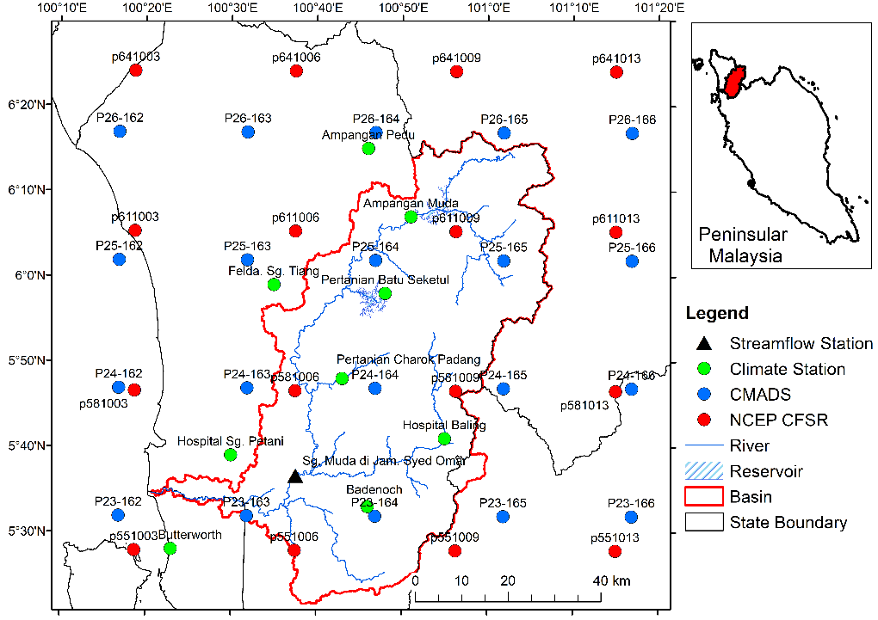
Figure 1: Example study area map.

- Materials and Methodology
  - Materials
A brief geographical description of study area with at least one figure to show the location. A standard map should contain coordinates, north arrow, scale and legend.

Table 1:
No | Name | Latitude | Longitude
1 | XX | XX | XX
2 | XX | XX | XX
3 | XX | XX | XX
4 | XX | XX | XX

  - Methodology / framework / theory
Please describe the overall workflow of your study as details as possible. We encourage to prepare a figure represents the entire workflow / framework / theory.

- Results
  - Result 1
In the results section, simply describe the major research findings that you discovered.

  - Result 2

  - Result 3
- Discussion
Article Journal of Asian Geography, 2021, 1(1), 1-10. doi: https://XXX

This section should answer the questions of what do your results mean? Compare your results with those from other similar studies, either your results similar or difference with other works. Please provide reasons the statements. In addition, you can also include limitations of current work and some suggestions to improve in the future.

- Conclusions
This section should summarize the findings as simple as possible. Authors do not need to include statistical values that have been mentioned previously in the results section.

Acknowledgement
Authors should acknowledge any funding or technical support in this section.

Conflicts of Interest
Authors should declare any conflicts of interest or state “there is no conflicts of interest in this study”.

References
Please refer to the American Psychological Association (APA) style in the citations and references of this manuscript. A complete guide of APA in-text and reference list is available at https://www.mendeley.com/guides/apa-citation-guide.

